Moodle User Guides for Trainers

Table of Contents

Create an event 1
See e-learning data 1
See quiz data 2
See results from a poll 3
See who has or has not viewed or partaken in a piece within a course 4
See who is currently online and what they are viewing 5
See how many views / entries different documents within a course have had 6
View Feedback 7

For more guides on how to use Moodle see the Moodle User Guides and First Time user Guides documents in the Help with Moodle section

Create an event

- Log in to Moodle
- Access the course page for the event you want to create (See the Moodle User Guides document if you don’t know how to do this)
- Find the Upcoming events block and click New event
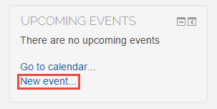
- In Type of event choose Course to add everyone on the course to the event (Choose Group to only add a selected group to the event, then select the group form the group event menu)
- Fill in the required fields giving all details of the event, click Save changes
The event will now appear in all participants calendars and will also appear in their Upcoming events block

See e-learning data

- Log in to Moodle
- Go in to the course the e-learning is in eg. Firefly
- Locate the e-learning module and click on it
- Click Reports
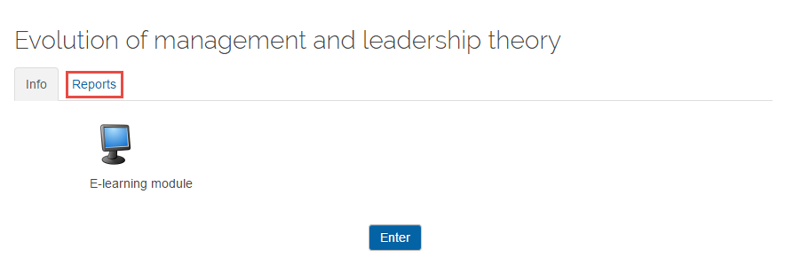
- Data regarding participation and completion of the e-learning will be shown, if you would like to download the data into an Excel spread click Download in Excel format
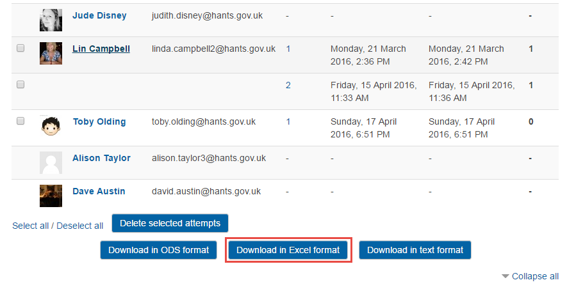

See quiz data

- Log in to Moodle
- Go in to the course the quiz is in eg. Firefly
- Click on the quiz section
- Click on the name of the quiz
- In the administration block under Quiz administration click Results
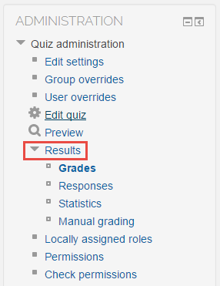

- Click Grades
- Make selections in the What to include in the report section to choose what data you want to see
- Click Show report
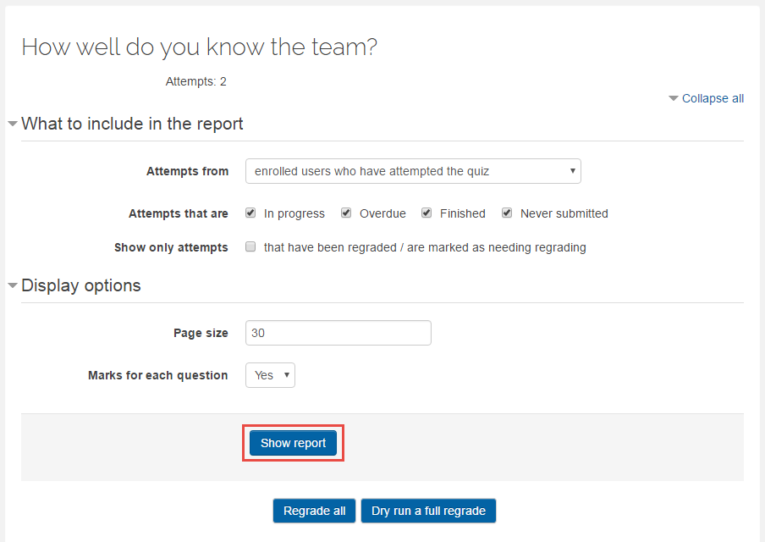
- All data will be displayed in a table, you can also choose to see Responses, Statistics and Manual grading data
- To download the data to an Excel spreadsheet, in the field next to Download data table as choose Excel spreadsheet and click Download

See results from a poll

- Log in to Moodle
- Go in to the course the poll is in eg. Firefly
- Click on the poll section
- Click on the name of the poll
- Click View responses (If ten people have completed the poll it will say View 10 responses ect)
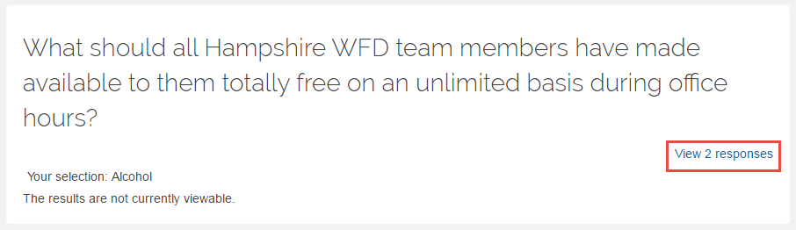
- To download the results into an Excel spread click Download in Excel format

See who has or has not viewed or partaken in a piece within a course

You also have the ability to send a personal message to some of or all of the students on the course. You may want to do this, for example, if you have checked to see which students have completed a section within a course and you want to message everyone who has not completed it asking them complete it

- Log in to Moodle
- Go in to the course you would like to check student participation
- Click Reports
- Click Course participation
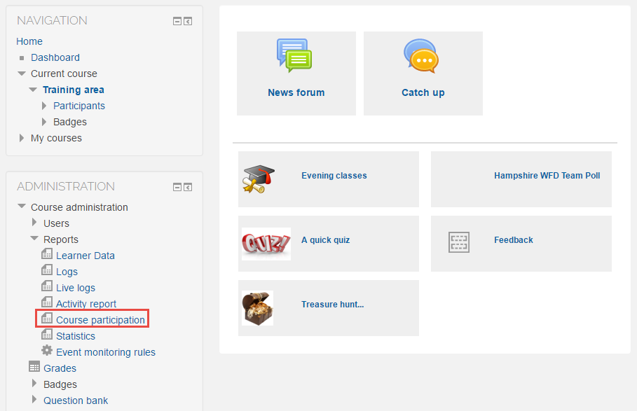
- Under Activity module choose what you would like to see data on
- In the field next to Look back select how far back you want to check data from
- In the field next to Show only select Student
- In the field next to Show actions select whether you want to see all participation (All actions) or just who has viewed (View) or posted (Post) in that activity
- Click Go
- Results will be displayed in a table. To message everyone in the table click Select all, to message everyone who has not completed the selected actions click Select all ‘No’ or to message certain individuals click the square box to the right of their name
- Under With selected users… select Send a message
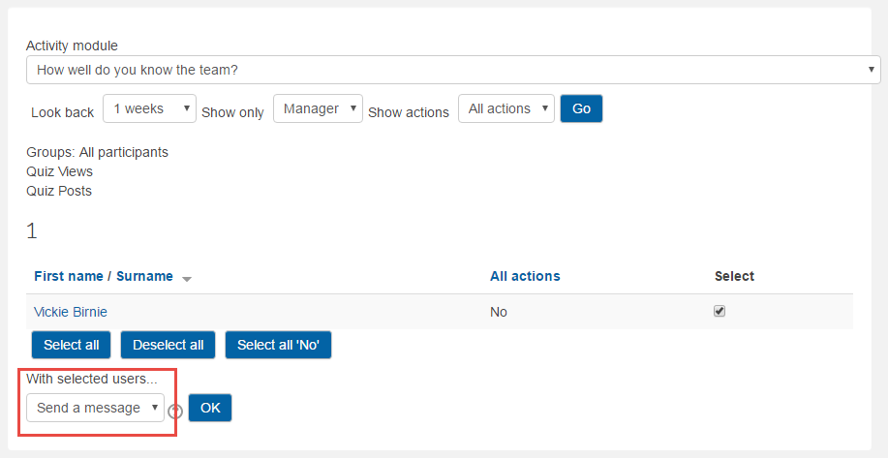
- Click OK
- Type your message in the Message body field
- Click Send message

See who is currently online and what they are viewing

You may want to use this feature if you would like all students to be logged on and in a certain place at the same time

- Log in to Moodle
- Go in to the course from which you want to check students are using
- Click Reports
- Click Live logs
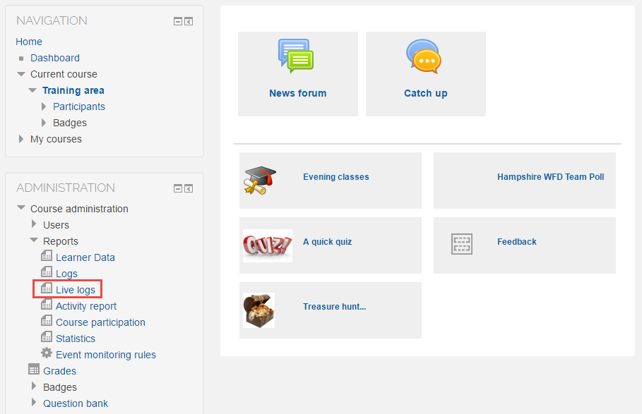
- Results showing who is logged in and what they are viewing will be shown in real time

See how many views / entries different documents within a course have had

You may wish to use this feature to see how popular and used a document or activity is within a course
- Log in to Moodle
- Go into the course you want to see data from
- Click Reports
- Click Activity report
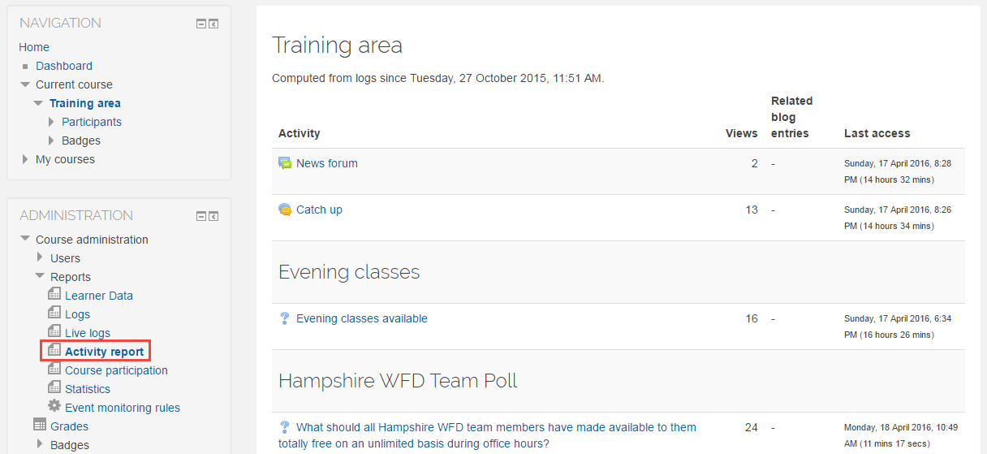
A table displaying Views, Related blog entries and Last access data will be displayed. There is no option to download or print this table so to do so you will need to do a print screen or select all the text and paste it into a Word or Excel document.

View Feedback

- Log in to Moodle
- Go into the course from which you wish to see feedback
- Click Feedback
- Click on the title of the feedback
- Click Analysis to see all feedback, if you want to save and export the results, click Export to Excel
- To see who has responded to the feedback click Show responses
- To show who has not responded click Show non–respondents.
- If you would like to send a message to all the non-respondents click Select all, otherwise tick the box at the right of their name to select individually
- Write your subject and message in the fields provided
- Click Send

