Moodle User Instructions

Contents
First log in and password change 1
Change your password 1
Set up your profile and add a profile picture 2
View and download course material 4
Book a date for verax 4
Send and access private messages within Moodle 5
Change message notification settings 6
Create a blog entry and adjust privacy settings 7
Add a new event to your Moodle calendar 8
Export your Moodle calendar 8
Link your Moodle calendar with your Outlook calendar 9
Read and reply to forum posts 10
View your grades and assessments 10
Use the Moodle app 11

First log in and password change

See the First time user guide document

Change your password

- Log in to Moodle and click on your name (top right of home page)
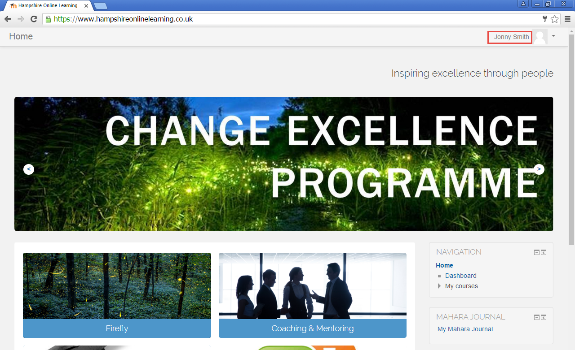
- From the drop down menu click Preferences
- Under User account, click Change password
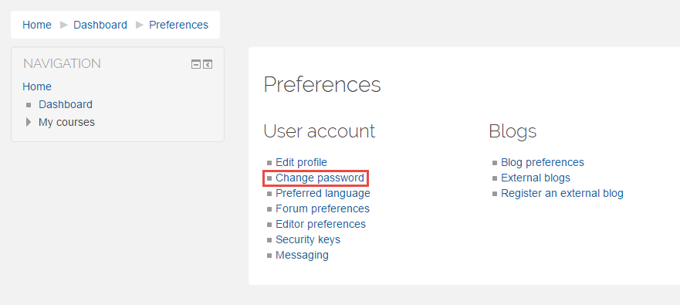
- Enter your current and new password in the fields provided
- Click Save changes

Set up your profile and add a profile picture

- Log into Moodle and click on your name (top right of home page)
- Click on Profile
- Under User details click Edit profile
- Make any updates as required
- To upload a profile picture, go to User picture and in the new picture area click the Add file icon
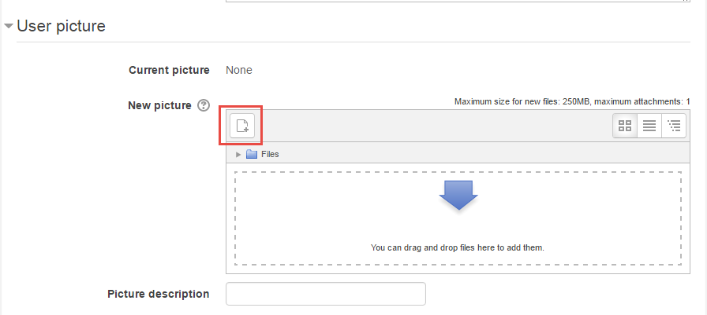
- Click Upload a file
- Find your picture, then click Upload this file
- Click Update profile (bottom of page)

Access your courses

- Log in to Moodle, scroll down the homepage until you see the My courses section
- Click on the required course
Or
- Log in to Moodle, locate the Navigation block on the homepage
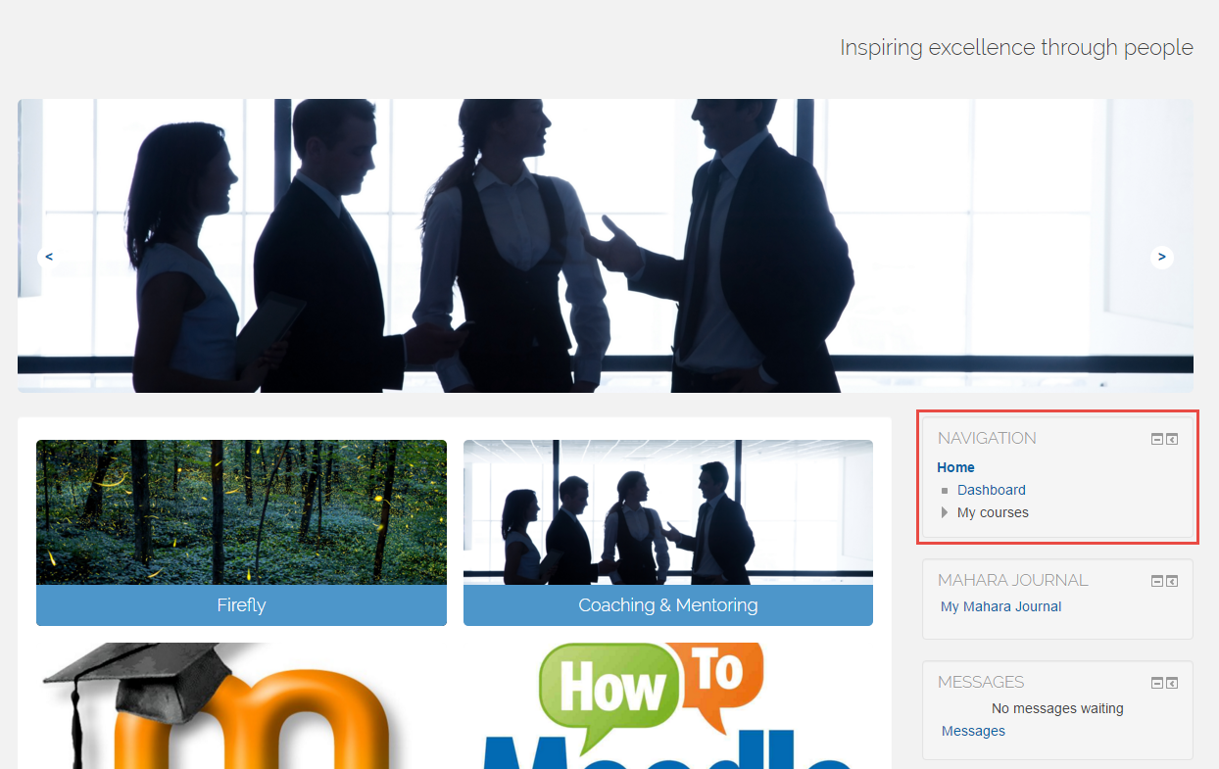
- Collapse the My courses menu using the small arrow icon beside it
- Click on the course you require

View and download course material

- Log in to Moodle, open the required course (see instructions above if unsure how do this)
- Scroll down the course page, all topics and materials will be in the centre blocks
- When you have found the file you want to view, single click on it
- A window will open asking what you would like to do with the file
  - To view the file click Open
  - To download a copy click Save as, choose where you want to save the file, click Save

Book a date for verax

- Log in to Moodle, go to the Firefly course page (see Access your courses if unsure of how to do this)
- Click on the Date for verax icon
- Select the time and date you want to book
- Click Save my choice (bottom of page)
- Save the date in your calendar so you do not forget

Send and access private messages within Moodle

- Log in to Moodle and click on your name (top right of home page)
- From the drop down menu click Messages
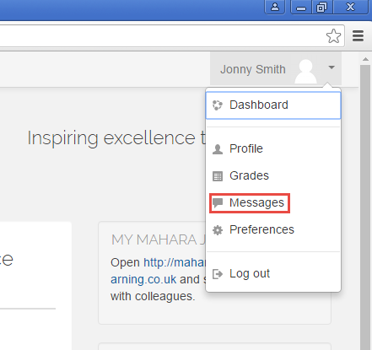
- Your messages will be displayed on this page. Click on a message to read it
- To send a message, from the Message navigation drop down menu, select your course
- Click on the Participant you want to message
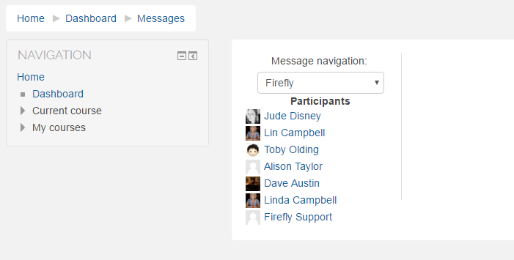
- Write your message in the Message box on the right
- Click Send message

Change message notification settings

- Log in to Moodle, click on your name (top right of homepage)
- From the drop down menu click Preferences
- In the Preferences panel, under User account, click on Messaging
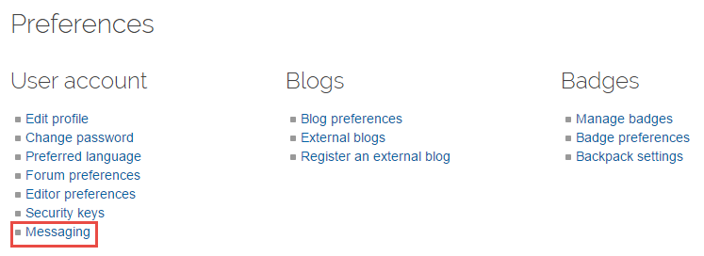
- Select how you would like to receive notifications buy ticking the relevant boxes
- Click Save changes

Create a blog entry and adjust privacy settings

- Log in to Moodle, find the Blog menu block on the home page
- Click on Add a new entry
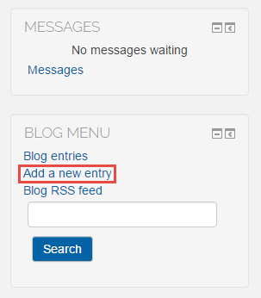
- Fill in the fields provided
- If you want to add an attachment to your post, in the Attachment section click the icon in the top left corner, click Browse, find your file, click Open, click Upload this file
- To set the privacy of your post, from the Publish to drop down menu, select Yourself (draft) if you do not want the post to be seen by anyone but yourself or select Anyone on this site is you would like your post to be visible to anyone using the Moodle site
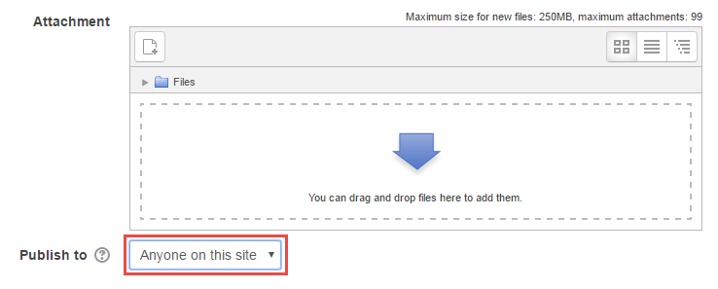

Add a new event to your Moodle calendar

- Log in to Moodle. Open the course you want to add the event to (see Access your courses if unsure of how to do this)
- When on the course page find the Upcoming events block
- Click on New event
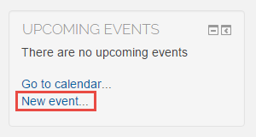
- Fill in the fields with details of the event
- Click Save changes
- The event will now be visible in your calendar

Export your Moodle calendar

- Log in to Moodle and find the Calendar block on your home page
- Click on the month displayed (top centre of the calendar)
- Under Detailed month view for, select whether you wish to export events for All courses or select a specific course
- Click Export calendar
- Select the data you want to export
- Click Export
- You will see a message, click the drop down menu arrow next to Save and click Save as
- Select where you want the calendar to be saved and click Save

Link your Moodle calendar with your Outlook calendar

- Open Outlook and have your calendar displayed
- Log into Moodle
- On the Moodle home page, find the calendar block and click the month displayed (top centre of calendar)
- Click Export calendar
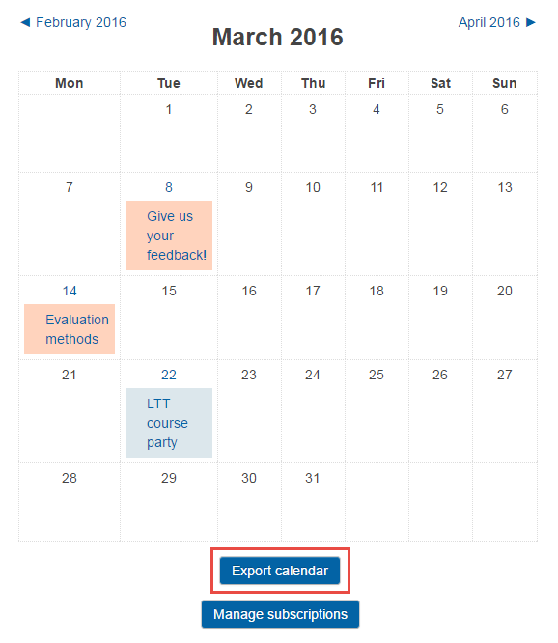
- Under Export calendar, select All events and Recent and next 60 days
- Click Get calendar URL
- Copy the URL displayed (Ctrl + C)
- Return to your Outlook calendar
- Right click on Shared calendars (left hand side of the calendar page)
- Choose Add calendar then From the internet
- Paste the URL you previously copied into the field displayed and click OK
- You will be asked if you want to Add this Internet Calendar to Outlook and Subscribe to Updates, click Yes
- Your Moodle calendar will now be displayed along side your Outlook calendar
- To merge the two calendars, click the arrow on the tab at the top of the Moodle calendar. Now click the tab of your Outlook calendar. Now when looking at your Outlook calendar you will also see any events that are also in your Moodle calendar (they will be displayed in a slightly faded state)

Every time you launch Outlook the 60 days will reset from that time, so that the next 60 days is always displayed in the calendar

Read and reply to forum posts

- Log into Moodle and open the relevant course (see Access your courses if unsure of how to do this)
- Find the forum block (this will be in the centre of the page, you may need scroll down the page)
- Click on the Forum block (it may be called something relative to your course or module eg. Leadership forum)
- The forum will be open showing all current topics and who started each discussion. Click on the discussion topic which you are interested in
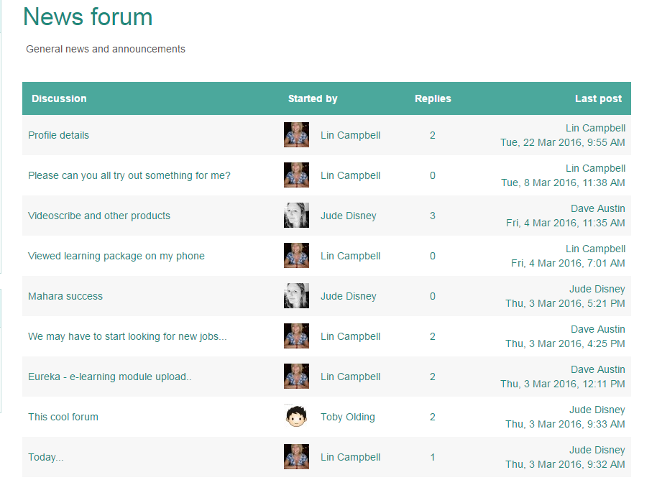
- All posts and comments will be displayed. To reply to a post click Reply in the bottom right hand corner of the relevant block

View your grades and assessments

- Log in to Moodle, click on your name (top right of home page)
- Click on Grades from the drop down menu
- In the Courses I’m taking section, click on a course
- The User report page will display your grades and assessments for that course

Use the Moodle app

- Download the Moodle app
- When asked to enter the address of the Moodle site you want to access, type: https://www.hampshireonlinelearning.co.uk
- Enter your username and password

