Moodle – first time user guide

First log in

The first time you log into Moodle, you will be asked to change your password.
Although there are no minimum requirements for your new password, you should make sure it is strong, and something you can remember.
To log in the first time:
- Open a web browser and go to: www.hampshireonlinelearning.co.uk
- Click Log in (top right)
- Enter the Username and Password you have been supplied and click Log in
- You will now be asked to change your password - enter the password you have already used in the first field, and a new password in the next two fields
- Click Save changes

Preferences

The first time you log in, you will be taken to the Preferences area.
There are a few fields that we recommend that you update.
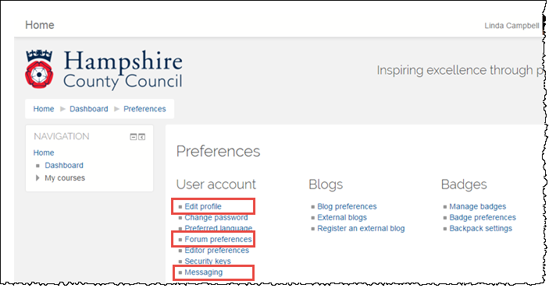

Edit profile
Click Edit profile
There are several headings, click on any heading to open it up and view all of the fields available.
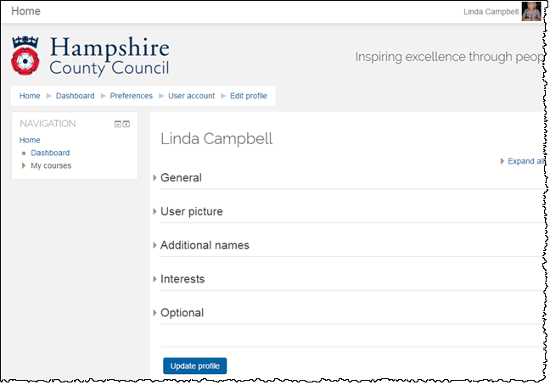
It’s up to you how much information you complete in your profile, but you should update the following areas:
General
Check all your personal details and in particular the setting under Email display (this denotes who your email address is shared with).
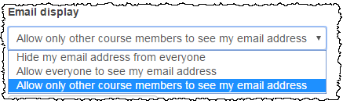
User picture
To upload a profile picture, click the Add file icon (under New picture heading), then Upload a file, browse to find your picture, then click Upload this file.
When you have completed all updates, click Update profile (bottom of page).

Forum preferences
This is where you decide how often, you want to be notified of updates to forums.
Under Email digest type decide on whether you want:
- An email to be sent for every new post – No digest (single email per forum post)
- One email per day with all forum posts – Complete (daily email with full posts)
- One email per day with just forum subjects – Subjects (daily email with subjects)
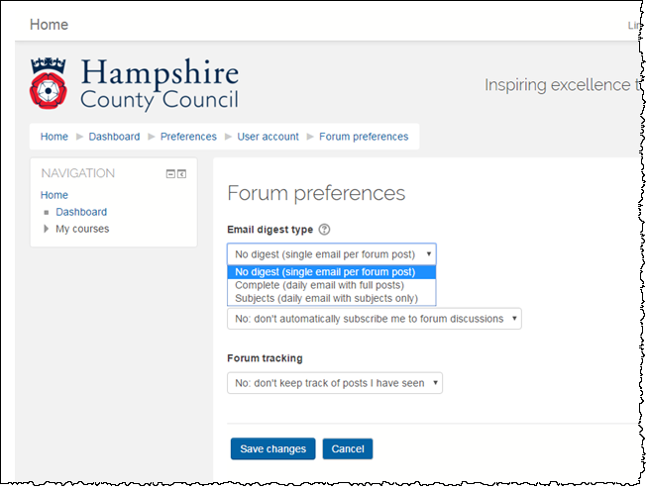
Click Save changes after making any changes.
Messaging
This area is where you decide how you want to receive Moodle system notifications when you are logged into Moodle, and are offline.
Just select options as appropriate and click Save changes (at bottom of screen).
