New Manager Programme
Learning Log

Contents

- What’s expected of me as a manager? – pre reading | 3-6
- Personal Development Plan – complete as pre work | 7-8
- Expectations of a Hampshire County Council Manager – Manager Competencies | 9
- Expectations of a Hampshire Constabulary Manager (and all staff) – the CVF | 10
- Optional pre reading - The Transition from Colleague to Manager | 11-14
Part 2 – Workbook for New Manager sessions  - Session 1 - Impact of your style, emotional intelligence, management & leadership | 15-17
- Session 2 - Set expectations, engage and support | 18-22
- Session 3 - Address underperformance and challenge unacceptable behaviour | 23-27
- Session 4 - Manage resilience and wellbeing | 28-31
- End of all sessions Action plan | 32

What do I need to do
Pre work | 1: Read pages 3-6
 | 2: Complete the development plan on pages 7-8
 | 3: complete the leadership styles quiz at New Manager: Leadership styles quiz (hampshireonlinelearning.co.uk)
Post-work | 1: Complete ‘Your Development Microlearning’
 | 2: Submit full manager development plan to hr.workforce.development@hants.gov.uk
 | 3: Complete review with line manager within 3-6 months

Part 1 – Pre Reading and Pre work
What’s expected of me as a manager?

While each of our partner organisations has specific frameworks that outline what skills, values and behaviours are expected of their managers, there are some areas that all partners identify as essential requirements for carrying out your management role effectively.
The model below is by John Adair, who identified that managers need to spend equal attention, at different times, on getting the Task done, building the Team, and looking after Individual needs. We’ve used this model to highlight some of the key things that are expected of you as a manager and that we will start to look at on this programme.
We’ve also added the need to spend time building your own skills and resilience into this model – a reminder to focus on You.
Fundamentals of effective management
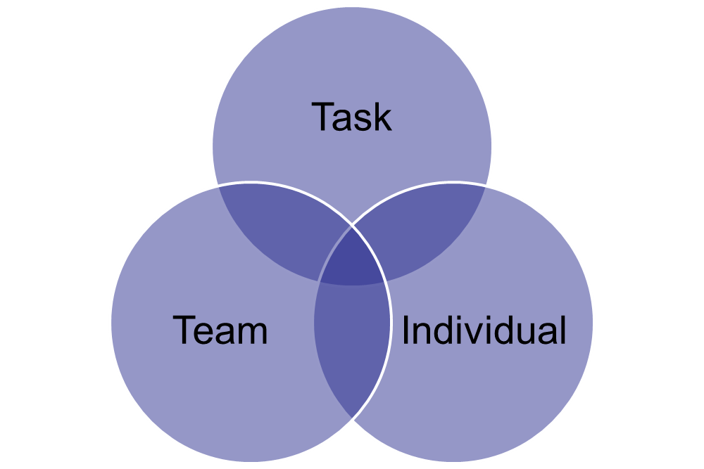
YOU
- Be self-aware
- Develop yourself
- Be a role model for values such as Inclusion and Diversity, ethical and professional behaviour
- Engage staff
- Manage your wellbeing and resilience
- Be aware of costs and inefficiencies
- Focus on delivering quality services
- Give people clarity on what they are here to deliver, what is important and why
- Hold people to account for their performance

- Value difference
- Be aware of unconscious bias
- Know and work with people as individuals
- Flex your style to get the best from people
- Set clear goals and give evidence-based feedback
- Value difference
- Build trust with the team and within the team
- Be aware of team dynamics
- Support improvements to team processes
Expectations around inclusion and Diversity
As a manager you should be aware of aspects of managing diverse people such as:
- Unconscious Bias (see below for more details)
- Providing opportunities
- Accessible and inclusive for all
- Recognising and adapting personal style
- Collaborative working
- Building rapport
- Building relationships
- Listen and show support to the employee
- Recognise and celebrate differences.

What is unconscious bias?

Unconscious biases are the automatic shortcuts our brains take without us even knowing it. It could also be called unintentional bias. There are 11 million bits of data going to our brains every second. Our conscious minds can only process around 40.

Unconscious decision-making and filtering of information is vital for us to be able to function in the world and process all that data. However, that means when we’re processing information every day most of our instant decisions and ‘gut feelings’ are done by the subconscious mind. These filters and beliefs were learned when we were very young and are now simply habitual – that is we do them without thinking. The downside is that they can be incompatible with our conscious values. ​

We all have some unconscious biases, and the key is to be aware of these unintentional habits so that we can recognise and challenge these.

Some ideas to get started are:
- Question your first impressions and be curious about your thoughts about other people – make this a new habit. Focus on people as individuals. Look for situational reasons for a person’s behaviour, rather than stereotypes about that person’s group​
- Consciously avoid exposure to negative stereotypes that can reinforce their influence on your behaviour​
- Build your empathy and Emotional Intelligence skills towards others in general. There are lots of resources for this online.

Engagement - Why the need to engage is so critical!

From an employee perspective, being engaged is about understanding our role and being clear and energised by where we ‘fit’ in relation to our organisation’s purpose and objectives. It is about feeling included as members of the team, having clear goals and being trusted and empowered to give and receive regular and constructive feedback.
Various studies have shown that engagement helps with retention, wellbeing, absence, reducing health and safety incidents, productivity, customer service, high standards (going the extra mile), and innovation – so you can see why the ability to engage people is a valued management skill.

An engaging manager:
- Makes each individual employee feel part of the team
- Ensures that everyone in their team has clear objectives and helps them to understand how their work contributes to the organisation’s objectives
- Coaches us and stretches us to bring out our best
- Gives us regular, thoughtful, honest and constructive feedback on our performance
- Understand the behaviours they expect, is able to articulate them and role model them. They are also prepared to challenge behaviours that fall short of their expectations
- Says ‘thank you’ and ensures that successes and achievements of individuals and teams are acknowledged – creating a culture of praise and acknowledgement
- Gets to know us and looks out for our welfare
- Is discreet and trustworthy

Accountability – Managing individual & team performance

As a new manager, it can be difficult to balance engaging people with ensuring they deliver their roles effectively. It can feel strange to tell other people what to do, especially if you have been promoted from within the team or if you are being asked to take on a temporary acting up role at short notice (see page 11 for advice on being promoted from within a team).

As you and your member of staff share responsibility for their performance, you absolutely have the right to ask people to carry out their roles. You are expected to set clear objectives and then give feedback against these.

We will look more at what accountability means during the programme, how it is different to blame, and how you can hold people to account in constructive ways.

Developing yourself and others –
Future Proofing you and your team

Why is it important?
Successful managers:
- take time to reflect on their strengths and development areas
- seek out and listen to feedback
- are always open to learning new things
- accept they are a ‘work in progress’
- role model being a committed learner
- take time to develop others by supporting development planning, asking coaching questions, and checking in pre and post course attendance

Completing a PDP will help you focus on the areas you want to develop. We will be asking you to make choices during the programme about what you want to ask, focus on and follow up on, based on this development plan.

Pre-work
Complete the development template on pages 7 and 8

How do I assess my strengths and development needs?

- Think about things that have gone well and that you are pleased with lately
- Also consider things that didn’t go as well as you would have liked
- Ask you line manager, colleagues and team members for feedback
- Think about your aspirations for your current role and future roles
- Review the competencies/values for your organisation on page 9 (HCC), 10 (HC) or and assess yourself based on these
Personal Development Plan -1
Pre work – complete before attending the first New Manager session.

How I know I am achieving this (measure)
What are your current strengths in the role?

What would other people who you work with say are your strengths?

How I will know when I am achieving this (measure)
What areas do you want to develop?

What could you develop even more?

Personal Development Plan -2

Expectations of a Hampshire County Council Manager – Manager Competencies

The Hampshire Manager manages self and others:
- Is self-aware, inclusive and accountable
- Actively engages and develops their team; through regular contact and dialogue
- Ensures staff have clarity, authority and support to deliver high quality outcomes
- Challenges unacceptable behaviour and addresses under performance
- Manages their wellbeing and supports others to do the same

The Hampshire Manager is professionally and operationally capable:
- Ensures compliance with and continuous improvement of organisational policies and standards
- Makes change happen, explaining reasons to staff
- Is politically aware and makes informed decisions and recommendations
- Is connected within and beyond the organisation

The Hampshire Manager manages effectively within our system:
- Is open to possibilities and innovation which challenge today’s wisdom
- Learns from our mistakes and treats these as opportunities to improve
- Is empowered to drive high performing services
- Empowers people and gives accountability to make decisions within their areas of accountability and relevant frameworks
- Ensures risk management actions are proportionate

The Hampshire Manager is business focused:
- Uses technology to deliver services and work in a flexible way
- Is financially astute, actively managing costs and allocating resources to priorities in the most efficient way
- Considers public value, customer focus and evidence when making decisions and recommendations
- Is an excellent commissioner of services and products, driving value for money and holding suppliers to account.

Expectations of a Hampshire Constabulary Manager (and all staff) - The Competency and Values Framework (CVF) from the College of Policing

From the CoP’s Overview of the Framework document:
The Competency and Values Framework (CVF) aims to support all policing professionals, now and into the future. It sets out nationally recognised behaviours and values, which will provide a consistent foundation for a range of local and national processes. This framework will ensure that there are clear expectations of everyone working in policing which in turn will lead to standards being raised for the benefit and safety of the public.

The framework has six competencies that are clustered into three groups. Under each competency are three levels that show what behaviours will look like in practice. All of the competencies are underpinned by four values that should support everything we do as a police service.
Optional pre reading - The Transition from Colleague to Manager

The transition from colleague to manager is tough. The first step on the managerial ladder is not without its obstacles and challenges – even more so if you are managing your former colleagues. You want to be respected, you want to be liked and most of all, you want to be good at your job.

In the past you were part of the team. You were a friend and a colleague. But you’ve been promoted and today, for the first time, you’re ‘the boss’. The full reality of this transition dawns on you, and a whole host of unexpected emotions, concerns, and fears surface.

There are several potential approaches that new managers might adopt that are not optimal. By telling you about them here, we’re hoping you’ll be able to avoid them.

‘Chosen One’

The Chosen One tends to emerge as a result of pride – and fear they won’t respect you. Once the Chosen One becomes a dominant managerial persona it’s difficult to let it go. Instead of allowing yourself time to settle in and earn the respect of your team through solid leadership, you might barge in and assume that your title alone is enough to make you a leader. After all people should respect you – you’re a manager, right? It’s your actions that will define you as a leader.

Common phrases to avoid:
- ”Because I said so.”
- “Because I’m your manager.”
- “Don’t question my authority!”

Your team will soon lose respect for you if they are confronted by the Chosen One. They will feel distanced from you and are unlikely to take you seriously as their manager. Possibly you won’t notice, as you are too busy being important, but before long you won’t have any idea what your team is doing – they won’t want to tell you – and so you won’t be doing your job properly.

It’s okay to want to be respected but – at the risk of sounding clichéd – respect has to be earned, which takes time. Being a manager is about the work you do on a day to-day basis, not the title you are given.

‘The Fixer’
The Fixer often emerges from a desperate desire to be thought of as better than your predecessor. You can lose focus on what needs to be done and instead spend time looking to score points off the previous manager, making promises for the future that you can’t keep.

Good management is not about measuring yourself against others, it is about providing your team with the tools they need to do their job well and supporting them on a day-to-day basis as they do it.

Common phrases to avoid:
- “Don’t worry – now I’m in charge we’ll get that sorted out.”
- “I’m not like (previous manager); I won’t side with the organisation over you.”
- “I promise you…”

In the short term this is a crowd pleaser which is why it can be so attractive, and addictive! Some of your team might think you are the best thing since sliced bread. But hold on there.

Unfulfilled promises end up causing resentment and are more damaging to your team’s morale, than a more realistic “I’ll look into it” (as long as you do!); or even saying “no”.

Be patient and give yourself time to find your feet. Listen to what people want and discuss their needs. But don’t overpromise and under-deliver.

‘The Blabberer’

The Blabberer can be a response to feeling you have lost your friends and their comradeship. Now you are a manager, you may be wondering if people will still see the same fun-loving person that you were when you were one of them.

The Blabberer is a particularly unhelpful persona for someone finding their feet as a manager. It tends to emerge as a strong desire to share the organisations more sensitive information with former colleagues. A desire to ‘keep in’ with the team by sharing juicy snippets of information from the boardroom.

Common phrases to avoid:
- “I really shouldn’t tell you this but…”
- “You will never guess what I have read!”

This is sure-fire way to lose the respect not only of your team, but also senior management. As a manager you will inevitably be privy to sensitive, even confidential, information. But remember it is exactly that – confidential.

Your relationship with your former team-mates will change when you become a manager – but that’s not a bad thing. Being a manager is not about winning a popularity contest, it’s about being a trustworthy professional. More than anything a team needs leadership, and it’s you that has to provide that leadership.

‘Poor Rock Star’

The essence of the Poor Rock Star’s approach is to let everyone know how tough life is at the top. The reasoning goes that, if you remind your team of your extra responsibilities, how much harder you have it than them, how you’d trade it all in to be one of the team again, they are sure to understand your plight and forgive your mistakes.

Common phrases to avoid:
- “I have so much work to do.”
- ‘You just don’t understand.”
- ‘I didn’t even want this job.”

Poor Rock Stars almost always fail to grasp, that in the same way nobody really cares if a millionaire is tired from flying all over the world to exotic places, your team doesn’t care that you have more work to do – that’s what you’re being paid for. Please just get on with it!

Ducking your responsibilities won’t inspire confidence in your abilities. Your team need you to be 100% engaged. Talk to your manager if you are not feeling confident or feeling swamped – it’s what they are there for.

‘Best Bud’

The Best Bud is a dangerous path to go down and can quickly divide your team.

As a new manager you might want to be sure that your ’best friend’ from the team is okay that you are now their boss. So, chances are you ‘accidentally’ make sure everybody knows that they are a little bit more special, a little bit more important, and a little more deserving of responsibility and praise than anyone else.

Common phrases to avoid:
“Andrew, you’re the only one I can rely on.”
“Me and Andrew are just going for a chat to discuss some things.”

The Best Bud approach is bound to cause friction between you and your team and make your Bud’s time at work trickier too. People should be judged on their performance and not on their personality. Positive and negative behaviour needs to be addressed with every team member in appropriate measure. Any assessment of performance should be based on merit and transparent criteria.

It’s tough moving from the security of being a team member to the exposed hill of management, and it takes time to adjust. Take that time, and work to avoid these common pitfalls. It’s worth it – for both you and your team!
Part 2 – Workbook for New Manager sessions

Session 1 - Impact of your style, emotional intelligence, management & leadership

Emotional Intelligence
Emotional Intelligence (EI or EQ) is a set of skills that help us better perceive, understand and manage emotions in ourselves and in others. Collectively they help us make intelligent responses to, and use of, emotions.
Think of Emotional Intelligence as being about:
- Self-awareness
- Self-management
- Social awareness
- Relationship management

This model gives more detail of how emotional intelligence can be demonstrated.
The outer grey areas show productive states
The inner areas with a blue border show unproductive states
The larger blue areas emotional intelligence competencies

Notes

Activity: reflection/ discussion questions
Think of someone you admire as a manager
- What aspects of emotional intelligence do/did they demonstrate?
- How do they make you feel? Write 3 words
- What is the impact on your work as a result?
- What can you take from this for your own development?

End of session learning log
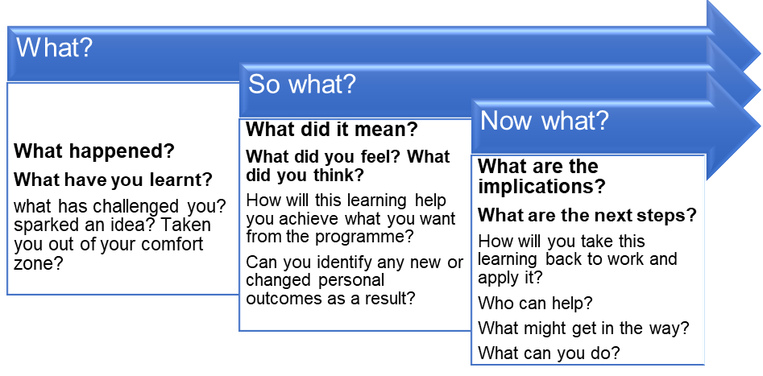

Session 2 - Set expectations, engage and support

Activity: reflection/ discussion questions

- What is the purpose of your team? What would happen if it didn’t exist?
- How does your team support the objectives of your whole organisation? (public value)
- How do you/ could you communicate this with the team?
- How can the team’s sense of why they do what they do help with their engagement?
- How do you set objectives with your team currently?
- How do you link objectives to development needs?
- How do you measure success?

Do you need to take any actions?

Start with why’

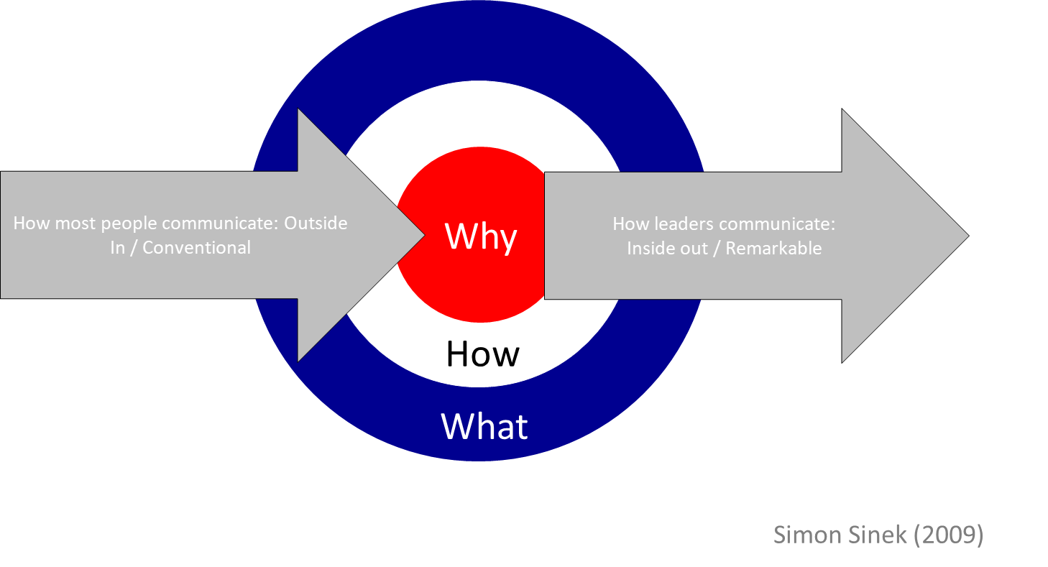

Start with why
This model shows the ‘Golden circle’- most leaders start from the outside in, they state what they do, how and then why, and most teams probably know what we do, how we do it, and maybe some can say why and link it to a purpose or a cause.

If Apple did it this way it would be – we make great computers (what), they are designed to be easy to use (how) , we want you to buy some (why).

Simon Sinek poses the question - why does your team exist, and why should anyone else care?

What Apple actually does is start from the middle of the circle and move out – start with why.
Everything we do we believe in innovating and pushing boundaries (why), the way we do this is by making our products user friendly (how) we just happen to make computers – wanna buy one? (what)

The message is - people don’t buy into what you do, they buy into why you do it
Inspired leaders work inside out – they ‘start with why’.

SCARF – what we need to feel engaged and motivated

Examples?

Activity: Which area should you think about in these scenarios?
S-C-A-R-F
- You need to change someone’s job title
- You need one person to take on a special assignment
- There’s a restructure or other change to the team
- You are really worried about a piece of work, so you keep a close eye on it

Managing performance case studies

Case study A – Different styles? History?

Ralph-Employee
Joseph-Manager

Ralph has worked for the authority for 9 years. He has always been quiet and private and has produced consistently good work at a steady rate.
3 months ago, an internal restructure meant that Joseph became his line manager. Previously, Ralph had an excellent relationship with his line manager.

In the last few weeks, Joseph has noticed that Ralph is more and more quiet and withdrawn. His work rate has slowed, and he is not proactive in seeking solutions or completing tasks fully. At his last one to one, Joseph told Ralph how to improve the way he comes across in meetings. Ralph became extremely quiet and would not discuss the matter any further.

Since then, Ralph’s work has not improved, and Joseph needs to address the situation at the next meeting. Joseph is outgoing and confident and has little time for emotions at work.

Activity: Discussion questions
- Where might a sense of threat be coming from for either party? (SCARF)
- What does the manager need to keep in mind?
- What might have eroded trust?
- What can be done to build trust?
- How would you advise the manager to handle this? Top tips and first steps?

Managing performance case studies

Case study B – Open conflict? Right to manage?

Employee-Terry
Manager-Leona
Terry has been in his current role for 3 years. He is confident and often questions his line manager and is very aware of his rights. He’s really knowledgeable but has periods of demotivation that he is well known for.
In the last 6 weeks, his manager, Leona, noticed. work is becoming sloppy, containing basic errors. Leona brought this issue up and asked Terry if there was anything she should know. Terry became quite aggressive and challenged her authority. Leona calmed the situation, but the issue is still there, and she needs to raise it again.
Leona is quite new to her management role and lacks confidence. She worked with Terry in the same team before she was promoted to being his line manager. She found the previous meeting with Terry very challenging and is worried about how she will cope if he becomes aggressive again.

Activity: Discussion questions
- Where might a sense of threat be coming from for either party? (SCARF)
- What does the manager need to keep in mind?
- What might have eroded trust?
- What can be done to build trust?
- How would you advise the manager to handle this? Top tips and first steps?

Session 3 - Address underperformance and challenge unacceptable behaviour
‘Keep your cool’

Self-management
In any interaction, it is essential to avoid your own attitude being a factor responsible for generating or escalating conflict. Your attitude will be subconsciously conveyed to the person you are dealing with.
The way you think affects the way you behave. To break the cycle, you can’t change the other person, you can only change how you think and how you behave.

We can ultimately only be responsible for our behaviour, and how the behaviours of others are allowed to affect us.

A very important step in dealing with challenging situations is to put the blaming aside. When you blame someone, you tend to get angry, and act angry. When you are angry you are less able to deal with the challenging situation in a constructive way. You lose control.
It’s up to you. It does take two to argue. It takes two to escalate a small display of challenging behavior into a larger problem.
It means you, as recipient of the challenging behavior, often get to determine what happens, provided you use listening and questioning techniques, stay constructive, and manage your own emotional responses.

Labels are unhelpful – check for unconscious bias

Have you ever thought: -

“Oh, here comes John again, why is he always such a pain?”
or
“Why is Malika so strong willed? Why can’t she be easy going like me?”

We tend to characterise (or label) people and put them into boxes or categories.
We often label people and things almost automatically to classify and organise information to make our lives easier. Although our brains tend to label people as challenging, this creates unhelpful and unfair bias.

If you label a person as challenging, you are more likely to create more challenging situations with that person, since you will be expecting bad things to happen. Don’t create a self-fulfilling prophecy.

Managing Difficult Conversations- key points

Key things to remember
- Do something- it won’t go away on its own
- Plan, think about time, place
- Work out your intent – don’t label or blame- be clear on the purpose of the conversation
- Be clear (to the point) and factual
- Ask questions, invite their perspective and listen (you don’t have to agree)
- Manage yourself
- Have time out strategies ready
- Move forward by agreeing support and follow up

A structure for giving difficult feedback- remember AID?

(ACTION) When you.... come in late...(IMPACT) it has the effect that... it sets a bad example, the team have to wait etc. Must be real and observable (remember observation not judgement here – gets you off to a clear and factual start.)

Take a breath.

(DESIRED BEHAVIOUR) What I would prefer is for you to.... come in on time (paint the picture of what you do want them to do)

The benefits to you would be.... you won't have a disciplinary; you get your work done in time etc. (shows you care and helps motivate change)

The benefits to me would be.... I have the whole team together to give out the work; I don't get complaints from other members of the team. (Provides honesty and a reality check – explains why it matters to you)

Take a breath

What do you think about that?
They comment or justify…Oh but I have to take the kids to school, and I have to be late...

So what is your plan to do what is needed? (Put the ownership back with them).

Planning Difficult Conversations

Activity:

Option 1: If you have a performance conversation that you want to have, plan the following:

- What is the outcome you want?
- How will you open the conversation?
- What evidence do you have?
- What will you do to self-manage?
- What’s your strategy if either of you need a time out?

Share/ test out with your partner who will coach you using the GROW model

OR
Option 2: If you don’t have a conversation in mind, revisit the tips on page 24 and 25 and note some ideas to put these in place

Coaching – Manager’s toolkit - GROW model

Goal
Reflect on your aspirations and move the focus onto a specific, positive goal

Example questions:
- What do you want to have happen?
- What’s your future goal and what’s the next step towards that?
- What’s the outcome you want?
- What would you like it to be like?

Reality
Where are you currently?

Example questions:
- What have you tried so far?
- What resources do you currently have that will help here?
- What do you need to develop?
- What’s stopping you?

Options
By coming up with options ourselves, we are more likely to actually go away and make them work.

Example questions:
- What are your options?
- What else could you do?
- What will get the best result?
- Which is most practical?

Will/Way Forward
This is all about planning actions or things to do differently. Reflect on what you will do and check your motivation to do it.

Example questions:
- What will you do differently?
- What will you do first? … And then?
- What support do you need?
- What exactly will be different if you do this?
- How committed are you to this on a scale of 1-10? (If a 6-7 – what would make it a 9-10?)

End of session learning log

Session 4 - Manage resilience and wellbeing

Activity: Wheel of Life
- Select and label your eight segments to represent important areas of your life.
- Score each segment out of 10 based on how much time and attention you’re giving it. (0 means you’re completely ignoring it and 10 means it’s dominating you at the moment.) NB. 0 is in the center of the diagram and 10 is at the edge. Notice what pattern your wheel of life is.
- Give each of your segments a priority score (you can have several sections with the same priority if you like)
- Plot the scores you would like to have in two months’ time.
- Identify which segments you most want to concentrate on in the next two months (use your priority scores)
- What manageable actions or quick wins would have most impact to get your scores to where you want them to be?
2
4
6
8
10

0

Wheel of Life activity continued

Section name | Priority score (1-8) | Score out of 10 | Score I want in 2 months’ time | Something I can START doing or STOP doing to increase this score

Resilience and Wellbeing Conversation template for managers

You can use these questions as part of the performance management process or as standalone questions to support people at work and coach them to increase their wellbeing and resilience:
General Wellbeing Questions
- How are you feeling about your workload?
- How would you describe your stress levels at work on a scale of 1-10?
- What would help you to be more productive and focus more at work?
- How motivated are you to achieve your goals and objectives? On a scale of 1-10 where are you?
- What other factors are having an impact on your work, resilience, wellbeing and motivation?
- What can you do and how can I support you?

Questions to help deal with setbacks
- What is the set back? What happened?
- How are you currently responding (emotional, physical and behavioural consequences)?
- What can you do to take back control of the situation and learn from it? How can I support you with that?

Remember:
- Ask open questions so that you allow the person the chance to talk based on what they think rather than your judgements.
- Listen actively.
- Be curious about what is driving their behaviour.
- Everyone is doing the best they can with the resources they have. There will be a reason for their behaviour Hold them in unconditional positive regard i.e. do not judge and have belief that all signs of poor work or not desired behaviour is for a reason and try and find out what is going on. This does not stop you setting boundaries and high standards. You can do both.

Sphere of Influence

Activity:
- list things on your mind now:

- Now add these into the grid below by identifying if they are in your control, influence or out of your control.

- Discuss with your partner using the GROW model, or self-coach, particularly focusing on what do you need to do to let go of things you can’t control, and what can you do/ influence?

Within my control | I can influence this | Out of my control
What do I need to do to park this, move on or let it go?
What I can control – some ideas to use/build the influence I have
What I can control – some ‘quick wins’ to improve the situation
End of all sessions Action plan

Action I will take | Who/ where I will find support I need | When will I do this by | How will I know I’ve been successful?

Top tip: Plan to overcome barriers before you get to them

Putting learning into practice, taking the first step isn’t always easy.
If you identify any challenges in advance and plan how you will overcome these, you are much more likely to be successful. For example, if you know you have trouble starting a task, ask a peer or someone not in your team to check in on your progress.
Notes: what might get in the way and what will I do about it?

